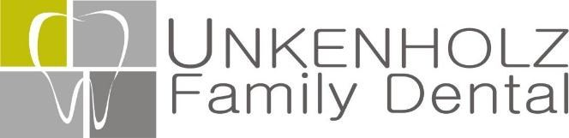
716 Quincy St.
Rapid City, SD 57701
605-399-9000
www.unkenholzfamilydental.com ______________________________________________________________________________________
ACKNOWLEDGEMENT OF RECEIPT OF NOTICE OF
PRIVACY PRACTICES

You May Refuse to Sign This Acknowledgement

I, __________________________________, have received a copy of Unkenholz Family Dental Notice of Privacy Practices.

_________________________________________
Please Print Name

_________________________________________
Signature

_________________________________________
Date

Names listed below have access to my dental records:

____________________________________

____________________________________

____________________________________
For Office Use Only:
We attempted to obtain written acknowledgement of receipt of our Notice of Privacy Practices, but acknowledgement could not be obtained because:
*Individual refused to sign
*Communication barriers prohibited obtaining the acknowledgement *An emergency situation prevented us from obtaining acknowledgement *Other (Please Specify):
______________________________________

